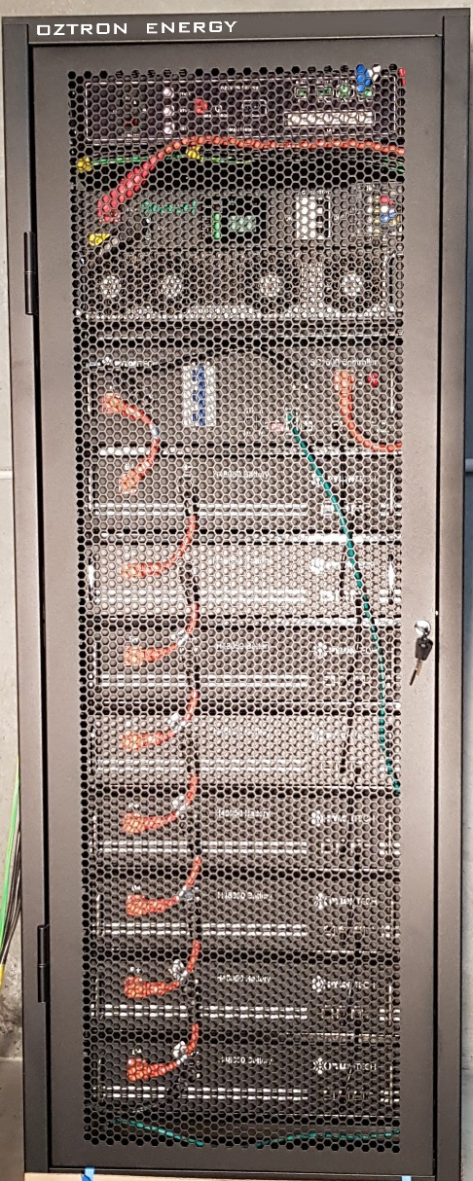
- Integrated MPPT, separate solar inverters not required
- Three phase industrial design
- Easy to install. Single, floor-standing unit instead of multiple boxes.
- Compact, Small footprint, self-contained
- Single connection going to the Distribution Board
- Automatic diesel generator management
- Indoor and Outdoor models
- Suitable for Microgrids
- Can be connected to grid if required

- Reduce diesel consumption
- Lower generation run time, lower maintenance
The OZTRON Solar-Diesel-Battery Hybrid Power System integrates solar for an off-grid site. It can reduce or eliminate the use of diesel generator and greatly reduce the operating cost.
Solar supplies most of the day-time load. The battery smooths out the fluctuations in solar output. The generator is switched on only when solar is low and the generator load is maintained at an optimum level.
The Hybrid system also smoothens a fluctuating load and presents even loading on the generator.
The cost of electricity generated from solar is about half that of diesel.

Solar-Battery-Diesel Hybrid Power System
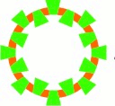 | Oztron  Energy  The Technology Source for Green Energy

Remote Monitoring & Management
The system is remotely managed to ensure optimum performance.
- Firmware upgrades
- Remote maintenance

- Conforms to Australian Standards
- Customized Energy Management System
- Customized configuration to suit individual needs
- Local support
- Modular construction, can be connected in parallel for higher capacity

- CEC approved 3 phase inverter
- Can operate with or without generator
- Can do Cold Start
- Lithium Ferrous battery, 10 year design life

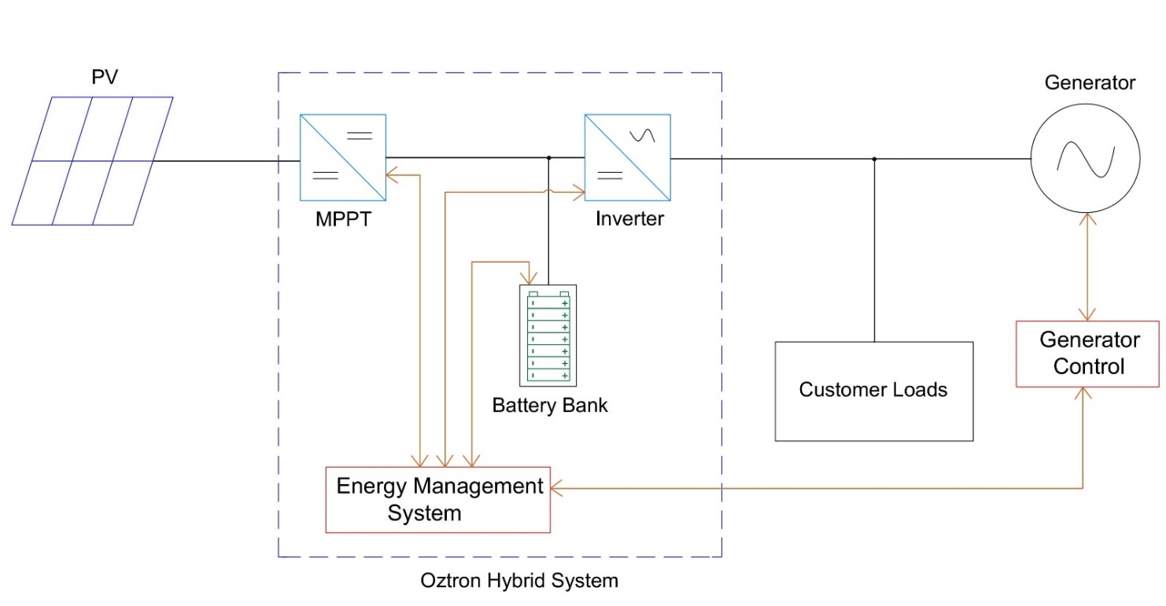

Specifications
Model | HST30-28 | HST50-66 | HST100-114 | HST100-133
Rated Continuous Capacity | 30kVA | 50kVA | 50kVA | 100kVA
AC Voltage range, 3φ (generator synchronized) | 329V to 459V
AC Voltage 3φ (stand alone) | 400V ±10%. settable
Frequency | 50Hz
Inverter Peak Efficiency | 95.5%
PV Voltage Range | 400V – 800V | 520V – 900V
MPPT Voltage Range | 400V – 600V | 520V – 800V
Number of MPPT inputs | 2 | 1 or 2 | 2, 3, 4 | 2, 3, 4
Maximum MPPT power | 50kW | 100kW | 200kW | 200kW
Battery Nom Voltage, V | 384V | 480V | 384V | 448V
Battery Nom Capacity | 28.4 kWh | 35.5 kWh | 113.7 kWh | 132.6 kWh
Usable full power autonomy | 45 minutes | 64 minutes | 54 minutes | 64 minutes
Parallel Operation | No | Yes | Yes | Yes
Isolation | No | Yes | Yes | Yes
Operating Temperature | 0 °C to 50 °C
Weight | 394kg | 828 kg | 1152 kg | 1344 kg
Size (W x D x H), mm | 600 x 600 x 2150 | 1400 x 800x 2150 | 1400 x 800x 2150 | 1400 x 800x 2150
Protection Grade | IP21
Communications | MODBUS TCP/IP, Optional 3G/4G
Certification | AS4777, VDE 4105, IEC62477, IEC61000, TUV, CE

Notes:
- Higher protection grade and outdoor type enclosures available for specific applications.
- Other battery configurations are also available.
- Larger systems are custom configured using multiple modules.
- Larger systems can be supplied in transportable shipping containers.

